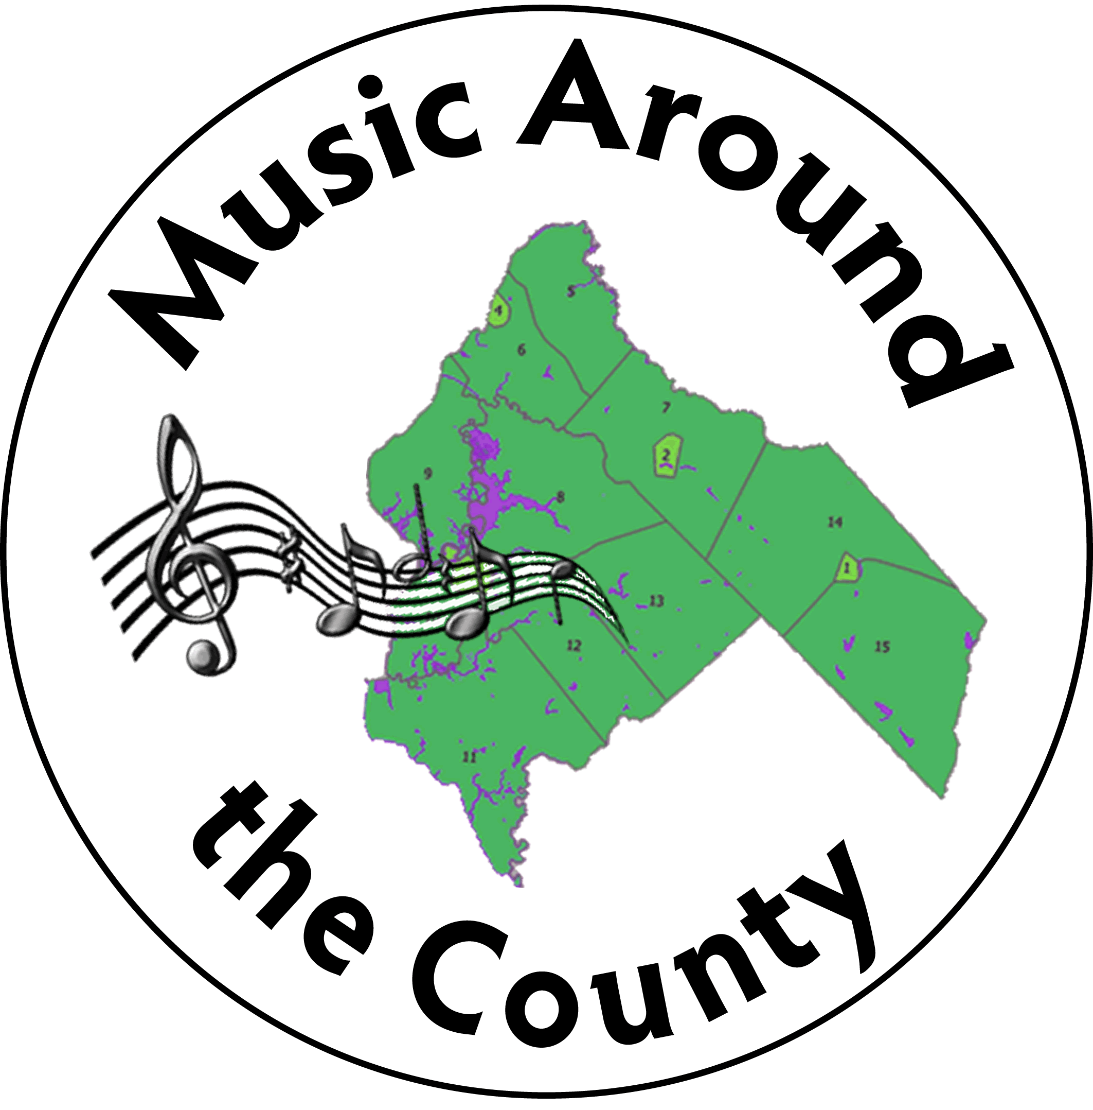

**Music Around The County**

**A Program of the Salem County Arts Alliance**

**2023-2024 Season**

Dear Friend:

Salem County’s ***Music Around the County*** 15th Annual Concert Series will soon be underway! The planning team is working hard to find imaginative ways to bring great music to Salem County. We are happy to announce a new season of live concerts.

*Music Around the County* will continue to bring quality local & regional artists to our community for FREE. How do we do this? … A dedicated core of volunteers, assistance from Salem County, the New Jersey State Council on the Arts, and freewill offerings at events. Promotion of events and honoraria are our biggest expenses. You, as our sponsor, are essential to our ability to keep music accessible to all our residents.

Among the musical offerings for our 15th season we are excited to have Beck’s Band playing newly discovered music from the 1860’s, and the Chestnut Brass, which will offer a clinic for students and an evening concert for the public. “Tunes from the Crypt” and “Pics and Pipes” – old “friends” to Salem County audiences – will return in the Fall. Brand new to the season are “Music for Flute and Harp” and “The New Jersey Chamber Orchestra.” And there’s more!!

Please see the season’s schedule of events included with this letter, and take a moment to review the tax-deductible sponsorship opportunities listed below. We appreciate your support *at any level*. Sponsors are recognized in our event programs, on our website, and on our social media. We hope you will be able to join us for this season’s concerts!

With Best Wishes,

<https://www.facebook.com/MusicAroundTheCounty>

<https://www.musicaroundthecountysalem.com/>

**Joanne**

Joanne K. Owen, Chair

🎜🎜🎜🎜🎜🎜🎜🎜🎜🎜🎜🎜🎜🎜🎜🎜🎜🎜🎜🎜🎜🎜🎜🎜🎜🎜🎜🎜🎜🎜🎜🎜🎜🎜🎜🎜

**NAME: _________________________________________________________**

🎜

**Company: ______________________________________________________**

**Address: _______________________________________________________**

**City: _____________________________ State: ____________ Zip: _______**

**Phone: _________________________ E‐Mail: ______________________**

**Enclosed please find a check in the amount of** $ ___________________

Please make checks payable to: **Salem County Arts Alliance**

Please send this form, along with your sponsorship donation to: MAC/ Arts Alliance P.O. Box 89, Pennsville, NJ 08070

**Sponsorship Levels:**

_____ **Symphony** $500.00 & up

_____ **Concerto** $250.00 to $499.00

_____ **Overture** $100.00 to $249.00

_____ **Sonata** $50.00 to $99.00

_____ **Fugue** $25.00 to $49.00

_____ **Etude** under $25.00